Holy Cross College

Semester 1 Examination 2015

Multiple Choice Booklet

Year 10 Science
(Extended)

Student Name
Student’s Teacher

Time allowed for this paper

Reading time before commencing work: 10 minutes
Working time for paper: 100 minutes

Materials required/recommended for this paper

To be provided by the supervisor

This Question/Answer Booklet
Data Sheet

To be provided by the candidate

Standard items: pens, pencils, eraser, correction fluid, ruler, highlighters.

Special items: non-programmable calculators satisfying the conditions set by the School Curriculum and Standards Authority for this course.

Important note to candidates

No other items may be taken into the examination room. It is your responsibility to ensure that you do not have any unauthorised notes or other items of a nonpersonal nature in the examination room. If you have any unauthorised material with you, hand it to the supervisor before reading any further.
SECTION ONE

1. What is a black hole?

(a) A rapidly spinning star which gives out neutrons.
(b) A dark invisible hole in space which is a worm hole into another parallel universe.
(c) A massive explosion which gives out huge amounts of light.
(d) The remains of a star which is so massive that light can not escape from it.

2. What are galaxies? Select the best answer from the options below.

(a) Huge masses of gas that explode.
(b) Collections of stars and solar systems and gas clouds.
(c) Shining objects in the sky.
(d) A star, along with its planets and their moons.

3. Which of the following best describes our view of the centre of our galaxy?

(a) We cannot see the centre of the galaxy.
(b) It is a small, bright cluster of stars.
(c) There is a black hole at the centre of our galaxy.
(d) The galactic centre is a faintly luminous cloud of gas and dust.

4. All known quasars are very far away. This is because quasars ...

(a) happened a long time ago.
(b) were once close by, but have been carried far away from us by the expansion of the Universe.
(c) are nearby but are hidden by clouds of dust and gas.
(d) are often hidden by planets.

5. A star like our Sun has a life cycle. Each of the lists below contains events from this life cycle. Which list has the events in the correct order?

(a) Nebula, protostar, star, red giant, planetary nebula.
(b) Protostar, planetary nebula, nebula, star, red giant.
(c) Protostar, nebula, red giant, star, planetary nebula.
(d) Nebula, planetary nebula, red giant, protostar, star.

6. If the light from a star is blue shifted, that tells us that ...

(a) the star must be moving towards us.
(b) the star must be moving away from us.
(c) the star must be moving parallel to us.
(d) the star must have a solar system of planets.

7. Stellar parallax occurs because ...

(a) the Earth changes position by 300 million kilometres every six months.
(b) stars travel very fast so they are in different places every time we look.
(c) the Universe is expanding.
(d) sometimes we approach a star, but six months later we move away from it.

8. A light year is defined as …

(a) the distance light travels from the closest star.
(b) the distance from Alpha Centauri to the sun.
(c) the distance of the Earth from the sun.
(d) the distance light travels in a year.

9. The main fuel of stars is …

(a) hydrogen.
(b) helium.
(c) carbon.
(d) gold.

10. Clouds of gas and dust that form spectacular images are _____.

(a) stars.
(b) nebulae.
(c) planets.
(d) suns.

11. The remains of a supernovae form a _____.

(a) red giant.
(b) nebulae.
(c) neutron star
(d) pulsar.

12. Most scientists currently favour the theory that the universe …

(a) once fit inside a pinhead before exploding out into a big bang.
(b) has always existed in its current form.
(c) began on a large scale, and is slowly shrinking so that it will one day fit inside a pinhead.
(d) has always existed and is continually expanding and contracting.

13. The nearest star to the Earth beyond the Sun is Alpha Centauri. Using current space vehicles, approximately how long would it take to reach Alpha Centauri?

(a) 80 000 years.
(b) 8000 years.
(c) 8 light years.
(d) 0.4 light years.

14. What type of reaction fuels the vast amount of energy produced by a star?

(a) Nuclear fission
(b) Chemical
(c) Physical
(d) Nuclear fusion

15. What is the most commonly agreed scientific theory for the creation of the universe?

(a) Darwinian evolution
(b) Theory of relativity
(c) Big Bang theory
(d) Multiverse theory

16. What is the correct scientific notation for one billion?

(a) 1 000 000 000
(b) 1 × 100⁹
(c) 1 × 10⁹
(d) 1000 × 10⁹

17. When was the Big Bang theory proposed?

(a) 1948 by George Gamow and Ralph Alpher
(b) 1933 by Albert Einstein
(c) 1927 by Fred Hoyle
(d) 1927 by Georges Lemaitre

18. To date, how far away is the most distant object in the known universe?

(a) 61 billion light-years
(b) 10 billion light-years
(c) 51 billion light-years
(d) 15 billion light-years

19. What is the key difference between the formation of a supernova and the formation of a white dwarf?

(a) The starting mass of the star
(b) The position in the galaxy
(c) If there are planets in the system
(d) Whether the star was hit by an asteroid

20. What does the equation E = mc² describe?

(a) The conversion of matter into energy
(b) The conversion of matter into entropy
(c) The conversion of light into heat energy
(d) The conversion of energy into gravity

21. What is Hubble’s Law?

(a) The closer a galaxy is, the greater its blue shift and so the faster it is moving away from us.
(b) The further away a galaxy is, the greater its red shift and so the faster it is moving towards us.
(c) The closer a galaxy is, the greater its red shift and so the faster it is moving away from us.
(d) The further away a galaxy is, the greater its red shift and so the faster it is moving away from us.

22. What do nebulas consist of?

(a) Asteroid belts
(b) Stellar clouds of gas and dusts
(c) Stellar masses of gas and energy
(d) Planets and their magnetic fields

23. Which of the following is the best definition of a star?

(a) A sphere of mostly hydrogen and helium gas that shines brightly and is held together by gravity
(b) A sphere of mostly helium gas that shines brightly and forms gravity
(c) A sphere of solid hydrogen that shines brightly and is held together by gravity
(d) A sphere of gas that shines brightly and forms gravity

24. If a planet is 0.5 light-years away from us, what is the distance between the planet and Earth?

(a) 1.5 × 10⁸ km
(b) 4.75 × 10¹² km
(c) 7.0 × 10¹⁷ km
(d) 9.5 × 10¹² km

- What does the Steady State theory propose?

(a) The universe and the galaxies in it stay in the same place.
(b) The universe has always existed.
(c) The universe remained at the same size after it formed.
(d) The universe maintains the same number of galaxies.

26. How many non-sex chromosomes are in a normal human sex cell?

(a) 46
(b) 44
(c) 23
(d) 22

27. What is a nucleotide?

(a) A basic unit of a DNA molecule
(b) A form of nucleus found in bacteria
(c) The membrane around the outside of the nucleus
(d) The nucleus of a sex cell

28. The gene for tongue rolling is a dominant trait, and the allele for it is represented by T. Frances has the genotype Tt and her husband Rohan is also Tt. What is the probability that they will have a child who cannot roll their tongue?

(a) ¾
(b) ½
(c) ¼
(d) 0

29. The pedigree diagram below shows how colour blindness is inherited in the family of Heather and Chris.

What is Angela’s genotype?

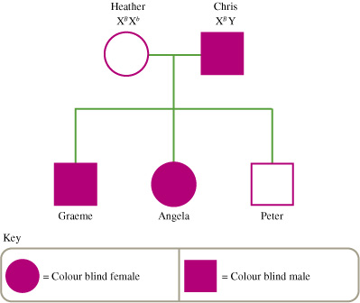

(a) X^{b}Y
(b) X^{B}Y
(c) X^{B}X^{b}
(d) X^{B}X^{B}

30. How is it possible for two brown-eyed people to have a blue-eyed child?

(a) The parents are both heterozygous for eye colour.
(b) The parents are both homozygous for eye colour.
(c) One of the parents is heterozygous for eye colour while the other is
homozygous.
(d) Eye colour is inherited by incomplete dominance.

31. What cells are referred to as somatic cells?

(a) Sex cells
(b) Any body cell that is not a sex cell
(c) A body cell that has a nucleus
(d) A body cell that does not have a nucleus

32. Sex cells are formed using which of the following biological processes?

(a) Mitosis
(b) Budding
(c) Binary fission
(d) Meiosis

33. What term means the same as ‘pure-breeding’?

(a) Heterozygous
(b) Homozygous
(c) Hybrid
(d) Dominant

34. If a genetic disorder is described as having an X-linked dominant inheritance, which of the following is TRUE?

(a) A father with the disorder will always pass it on to his sons.
(b) Only girls can have the disorder.
(c) A father with the disorder will always have daughters with the disorder.
(d) A mother with the disorder will always have sons with the disorder.

35. What is an allele?

(a) An alternative form or expression of a gene
(b) The phenotype expressed by a gene combination
(c) The position of a gene on a chromosome
(d) An inheritable trait

36. The gene that codes for colour in snapdragons has two different alleles: red (R) and white (W). If the colour of a snapdragon is inherited by incomplete dominance, what colour would a snapdragon with the genotype RW be?

(a) Red
(b) Pink
(c) White
(d) Red and white stripes

37. Which base binds to thymine?

(a) Thymine
(b) Cytosine
(c) Guanine
(d) Adenine

38. The table below shows some of the DNA triplets and the amino acids that they code for.

DNA triplet | Amino acid
AAT | Leucine (leu)
ACG | Cysteine (cys)
TAC | Start/methionine (met)
ATT | Stop
CGG | Alanine (ala)
CAT | Valine (val)
ATG | Tyrosine (tyr)
CCA | Glycine (gly)

What sequence of amino acids would be produced by the DNA section CATCGGCCACGG?

(a) Met-ala-tyr-ala
(b) Val-ala-gly-ala
(c) Val-met-gly-ala
(d) Ala-gly-met-cys

39. In pea plants, the gene for tall stems (T) is dominant over the gene for short stems (t). The phenotype for a pea with the gene combination Tt is:

(a) tall stems.
(b) middle-size stems.
(c) short stems.
(d) TT.

40. Which process causes changes in chromosomes to occur?

(a) Cell division.
(b) DNA mutations.
(c) Gene replication.
(d) Reproduction.

41. Dogs have 28 chromosomes in their skin cells. How many chromosomes does a haploid dog cell contain?

(a) 14
(b) 28
(c) 1
(d) 56

42. The DNA molecule is a double helix that may be likened to a twisted ladder. The 'rungs' of the DNA ladder are made of:

(a) amino acids.
(b) nitrogen bases.
(c) sugar units.
(d) phosphate units.

43. Which technique has been used to produce the wide variation in appearance of different dog breeds?

(a) artificial insemination
(b) cloning
(c) selective breeding
(d) embryo screening

44. In order to digest milk, adult humans need to have a gene that produces an enzyme called lactase. While now widespread, this gene appeared in humans only a few thousand years ago. Why has this gene survived?

(a) The mutation that forms the milk digesting gene keeps reappearing.
(b) Humans who did not have the gene died from milk poisoning.
(c) Humans with the gene were able to increase their chances of survival by having an extra source of nutrition.
(d) It was a mutation that did not disadvantage the humans who had it and so it did not die out.

45. How do new forms of genes appear in a species?

(a) One species mating with another
(b) They don’t — dormant genes already in the species are ‘switched on’.
(c) Mutation
(d) Absorbed from a prey species

46. How does immigration affect the genetic variation of a population?

(a) It may add new alleles to the population’s gene pool.
(b) It will decrease the number of alleles in the population’s gene pool.
(c) It decreases diversity.
(d) It usually has little effect as the immigrants will have the same genes as the resident population.

47. What is an adaptation?

(a) A characteristic that improves an organism’s chance of surviving in a particular environment
(b) A change in an organism’s DNA
(c) A characteristic that may cause an organism to modify its environment
(d) A change in the behaviour of an organism

48. What term is used to describe a factor that influences which variations give an individual a survival advantage?

(a) Attrition
(b) Selective pressure
(c) Genetic meme
(d) Adaptive strength

49 The image below shows a leaf-eating katydid insect. The males and the females look very similar. What is the most likely reason that they have evolved to so closely resemble a leaf?

(a) The katydids that resembled leaves were less likely to be eaten by predators and so survived to pass on the characteristic.
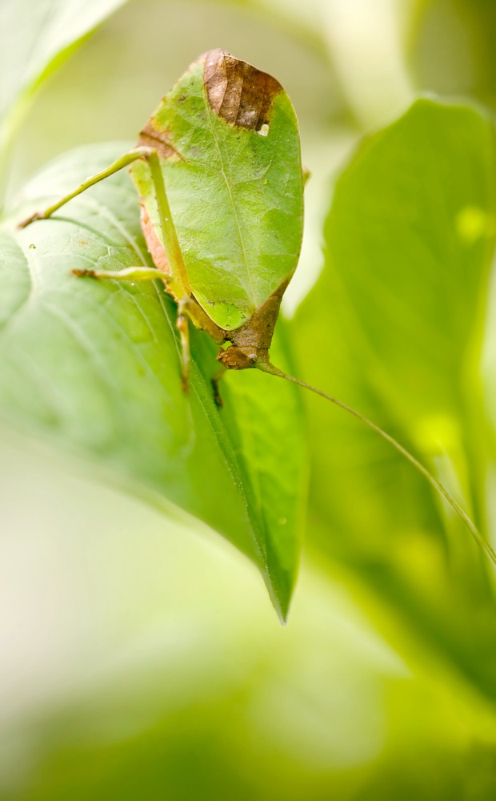
(b) The male katydids that resembled leaves were more likely to attract a mate and so were able to pass on the characteristic.
(c) The katydids that resembled leaves were better able to sneak up on their prey and so were more likely to survive to pass on the characteristic.
(d) The katydids that resembled leaves were more resistant to disease and so survived to pass on the characteristic.

50 The diagram below shows the speciation of different canids.

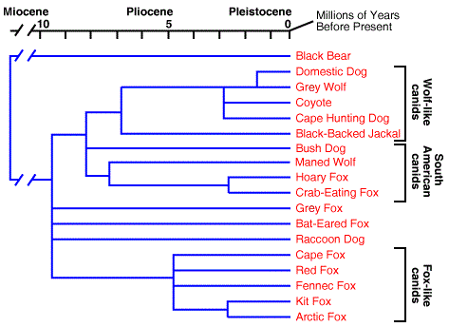
According to this diagram, approximately how long ago did coyotes evolve from grey wolves?

(a) 1.5 million years ago
(b) 3 million years ago
(c) 5 million years ago
(d) 8 million years ago

